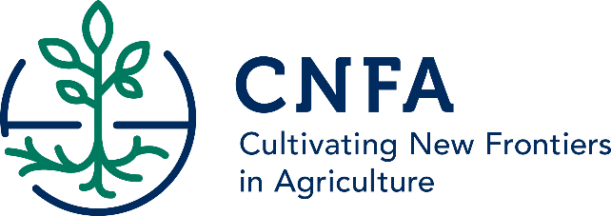
Location: Bulawayo (two positions)
CNFA is seeking applications for USAID/Zimbabwe’s Food for Peace Amalima Program. The Amalima program has the following strategic objectives: (1) improve household access to, and availability of, food (2) improve community resilience to shocks and (3) improve the nutrition and health of pregnant and lactating women, boys and girls under two.
The Monitoring and Evaluation (M&E) intern will report to and work directly with the Monitoring, Evaluation and Learning Manager. The intern will conduct learning unit research and support routine M&E work. She/he will support and learn all aspects of research, monitoring, evaluation and learning including but not limited to data collection, entry, analysis and report writing.
Specific duties
- Collect quantitative and qualitative data using both formal and informal approaches;
- Capture research data using appropriate software for analysis;
- Participate in data analysis and interpretation of results;
- Maintain a credible filing system that allows for easy retrieval of documents;
- Capture Amalima activity and outcome data from hard copy registers into an electronic database;
- Perform other support tasks as required;
- Other duties assigned by Monitoring, Evaluation and Learning Manager.

Qualifications
- A student studying towards a Bachelor’s degree in Research Methods and Quantitative Skills (including software), Agriculture, Nutrition, Communications/Writing or other relevant field
- A strong interest and solid foundation in research methods and tools is required
- Must have a support letter from their learning institution
To apply
Qualified candidates should send their detailed CVs and cover letters to: Amalima.consultancy.services@gmail.com and write title of the position they are applying for in the subject line by 28th July 2017.
Female candidates are encouraged to apply.

