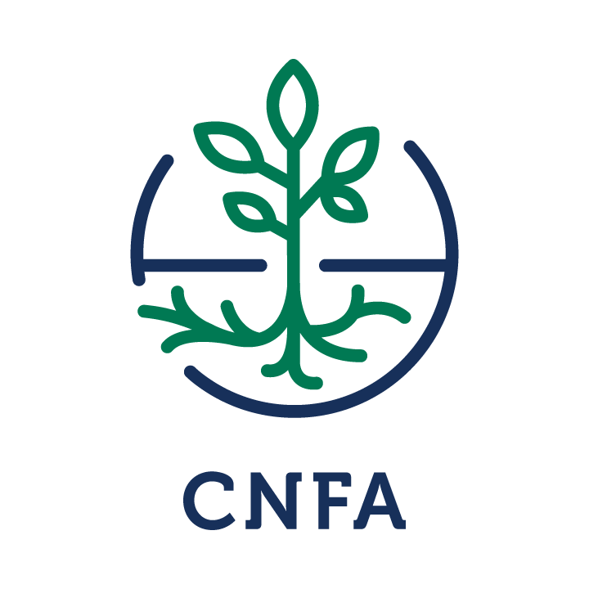
Date of Submission: | March 15, 2017
Assignment Location: | Minia
Scope Developed By: | Taher Yehia

Assignment | Dates | Objectives
Table grapes good agriculture practices (GAP), harvest, handling, and postharvest trainings | April 2017 | Improve farmer’s technical knowledge and practical applications to increase their incomes by improving quantity, quality and reducing losses of table grapes in Minia

- Desired Qualifications of Volunteer

- Experienced in global GAP requirements for table grapes
- Extensive practical experience managing grapes vineyards
- Knowledge of harvest, handling and postharvest techniques of table grapes
- Patience and positive attitude when working with local Egyptian farmers
- Must be citizen or permanent resident of the U.S.

- Host Background

Table grapes are considered the top deciduous fruit crop widely grown in Egypt. It is present in the seven targeted Feed the Future Egypt Food Security and Agribusiness Support Project (FAS) governorates of Upper Egypt. According to the latest 2015 statistics from the Egyptian Ministry for Agriculture and Land Reclamation (MALR), table grapes occupy 39,085 acres (37,224 feddans) in the seven governorates of Bani Suef, Sohag, Assiut, Minia, Luxor, Qena, and Aswan. However, Minia governorate is the largest in its cultivated area with 25,098 Feddans and subsequently with the largest number of table grape farmers. The recent Value Chain & End Market Analysis studies conducted by FAS showed that table grape productivity varies sharply from one governorate to the other. The highest productivity was noticed in Bani Suef which averaged 11.77 MT/feddan and the lowest was recorded in Qena which averaged 5.91 MT/feddan. This shows that there is opportunity for smallholder farmers to improve the productivity and quality of their orchards, which will result in an increase in smallholder farmers’ incomes. Technical trainings on GAP, harvesting, handling, and postharvest handling will can contribute to improving incomes. Starting from Minia, there are table grape farmer groups identified by the FAS agronomy team and Technical Advisor for Associations who will benefit from different project activities. And grapes growers in other governorates will follow.

- Issue Description

FAS works to increase agriculture-related incomes of smallholder farmer in Upper Egypt using a market-driven approach that facilitate sustaintable, pro-poor value chain development and helps smallholders increase access to domestic and export markets. This market-driven approach is support by four interrelated components:
- Improved on-farm production
- More efficient post-harvest processes
- Improved marketing of agriculture crops and products
- Improved nutrition status, especially for women and children

Table grapes are one of the key fruit value chains in Upper Egypt that are targetted by FAS. There are a substantial number of groves throughout the area and there are numerous opportunities for smallholder farmers to vertically integrate themselves into the table grape value chain by engaging in better production and post-harvest processes, as well as the export of grapes to Gulf countries, Africa, and Europe. However, grape orchard management in Egypt is subject to numerous ineffiecient practices such as dormancy breaking and controlling bunch shape and berry sizes which hinder the profitability of this value chain and limit the productivity of smallholders. Local farmers’ knowledge of integrated managment practices is limited and managment plans generally do not exist. Farmers do not have the technical knowledge to identify common diseases and pests as well as what treatments and/or protective measures should be done to minimize the disease or pest’s effects.

The host therefore has requested for a volunteer to train them good agriculture practices of table grapes in Upper Egypt as well as the most effective treatments and protective measures to pest control, pruning, harvest, and handling. The volunteer will visit farmer grape groves to assess the current needs and conduct trainings with farmer organizations on these topics, as well as work with the FAS technical team to put together a training regimen for future trainings for additional farmer groups.

- Deliverables
- CNFA’s Training Beneficiaries Record, Volunteer Value Reporting System Survey, and Trip Report. These documents must be completed no later than a week after assignment and preferably before the last day on assignment.

- Desired Outcomes and impacts

Desired Outcomes | Desired Impacts
- Improved technical knowledge of table grapes GAP and integrated management for both farmer associations trained and FAS technical staff | - Increase in smallholder farmers’ ability to effectively manage their orchards to increase their incomes

- Itinerary for assignment – Grapes GAP

Day | Activity
Day 1 | Pick up volunteer at Cairo Airport  Give welcome packet to volunteer  Volunteer exchanges money and purchases items that s/he might need  Volunteer checks in a Hotel in Minia (Booking already done by field staff)
Day 2 | Volunteer is picked up from the hotel and brought to FAS office in Minia.  Briefing is conducted, volunteer is given an overview of the assignment at FAS office. The volunteer will meet with the FAS production and post-harvest team to discuss common orchard management issues that affect smallholder farmers and review the current approaches used by farmers. Initial training topics will be discussed and an outline for farmer association trainings will be developed.
Day 3 | FAS coordinator escorts volunteer to the targetted farmer associations.  Volunteer is oriented on how farmer associations operate, their objectives, values, missions, suppliers, potential markets, constrains/problems and methods of approach. Volunteer works with local consultant to understand various agriculture practices that have affected their farms in the past, what was done to solve the problems, and the results.  Volunteer shares notes with the local consultant and production team leader. The aim of this is for the volunteer to have a clear understanding of what the associations do and what they want and make any initial suggestions for modifications to the assignment, if applicable.  Volunteer will return to Minia in the evening.
Day 4 | Volunteer visits several different grape groves to identify present agriculture practices and gaps. The volunteer will also discuss with farmers any issues they have encountered that affect their profitability.
Day 5 | Volunteer will return to Minia to develop a training regimen for the farmer associations with FAS technical staff. The training regimen will be finalized and shared with the technical team.
Day 6-10 | Farmer Training  The volunteer will travel to multiple farmer associations to train them on GAP, identifying common management practices, mitigating their negative effects, proper treatment methods, how to develop a pest treatment plan, and identifying available and necessary inputs for treatment plans. The volunteer should focus on cost effective methods bearing in mind the size of the farmers and the available technologies and inputs in Upper Egypt.
Day 11 | Training of FAS Staff  The volunteer will assist with a training of FAS technical staff working with farmer associations to identify and mitigate common negative practices, how to develop disease and pest management plans, and what are the best treatments and techniques to increase production, quality and minimize losses.
Day 12 | The FAS Chief of Party conducts a debriefing with the volunteer for the assignment where the volunteer is able to share ideas and suggestions for future trainings and approaches and point out gaps and best practices that should be noted during the assignment.  The volunteer drafts a trip report and other required documents.
Day 13 | Volunteer departs via Cairo airport.

Accommodations:
While in Minia, volunteers stay at the Grand Aton Hotel. This is located on the bank of the Nile in Minia and located close to several food options and easy transport to the FAS office via taxi.

Volunteer Preparation:

- The month of April is the spring season in Egypt. Volunteers are encouraged therefore to bring some clothes for warm weather.

- CNFA volunteer assignments require some pre-departure preparation by the volunteer, since time in country is limited. Please consult with your CNFA program officer or field staff for any information or assistance you need to properly prepare for your assignment. Needed materials can be discussed with in-country staff, via email, prior to departure.

- The volunteer will have full access to an FAS laptop computer, flip-chart stand, and other office equipment. Please inform FAS staff if training will require additional resources.

- The use of slides, videos, overheads, PowerPoint presentations and hands-on activities to emphasize main points are strongly recommended during your assignment.

Outreach:

CNFA requests each volunteer to complete outreach activities after returning from an assignment. Volunteer outreach helps foster cultural understanding and spreads the word about U.S. international development efforts. Outreach activities include any conversations you have about your project, newspaper articles, presentations, social media posts, or other events. Please keep this in mind during your project, and ensure that you are taking notes to correspond with photographs, meetings, or notable activities. Your Washington DC coordinator will follow up with you both during debriefing and again several months after your assignment is completed to get an update of your outreach efforts.

Project Contacts:

CNFA –Egypt
Taher Yehia  Team Leader, Production  FAS Program  Egypt  011 20 (0) 1140282222 [mobile]  tyehia@egyptfas.org | Millie Gadbois  Chief of Party  FAS Program  Egypt  011 20 (0) 1026901111  mgadbois@egyptfas.org

Previous Volunteers
None

