RESILIENCE AND ECONOMIC GROWTH IN THE SAHEL – ACCELERATED GROWTH
(REGIS-AG)

Newcastle disease: an obstacle in the development of the Nigerien poultry value chain

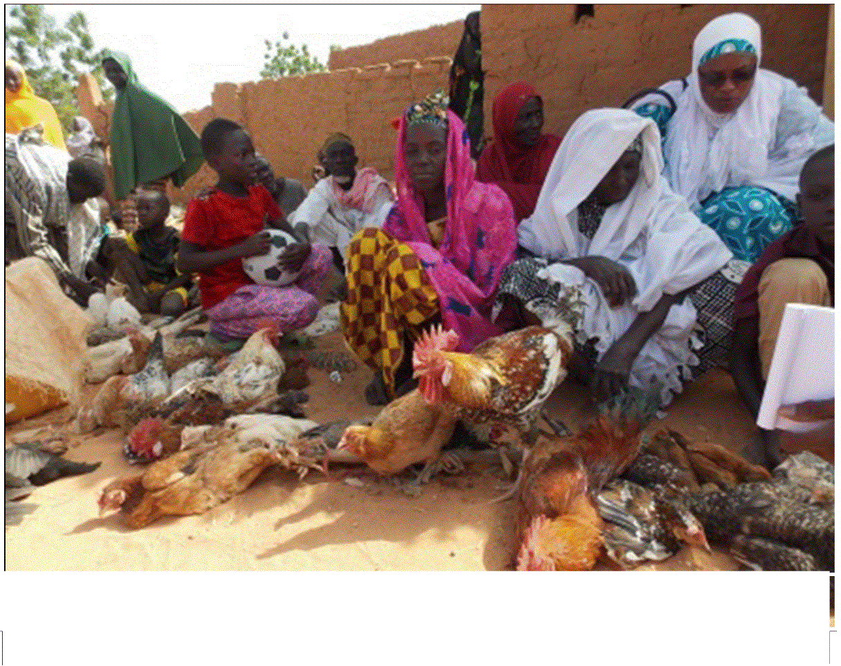
Newcastle disease is a highly contagious viral disease negatively affecting poultry in the West African region, where 40-70% of unvaccinated rural poultry are killed by the disease. The risk and impact of the virus, which spreads easily throughout flocks, can vary in severity from strain to strain and is also dependent on environmental conditions (such as immunity and the animal’s overall health). Outbreaks can occur at any time of the year, but happen with greater frequency during the cold season. Vaccination is the only prevention method for this disease and there is currently an effective, affordable vaccine (50 CFAF / subject) that is heat-stable and easy use for the smallholder farmers (administered by eye drop) that is produced in Niger. The vaccine is called I-2 vaccine (produced with strain I-2 virus) and is critical in the effort to promote animal health in Niger and the Sahelian region.

Mobilization of REGIS –AG and its partners in promoting animal health

Region | Chicken | Guinea fowl | Pigeon | Duck | Other | Total
Filingue | 60006 | 10045 | 3424 | 2743 | 8 | 76226
Tera | 110775 | 35803 | 12298 | 8004 | 86 | 166966
Say | 125044 | 23981 | 3542 | 3573 | 78 | 156218
Tillaberi | 65475 | 14586 | 8434 | 4573 |  | 93068
Kollo | 75220 | 15829 | 4818 | 1195 | 2 | 97064
Ouallam | 105486 | 20338 | 7446 | 852 | 40 | 134162
TOTAL | 542006 | 120582 | 39962 | 20940 | 128 | 723704
To significantly reduce the mortality rate of poultry in Niger, the NGO « Poulailler du Développement » provided the I-2 vaccine and sought the support of REGIS -AG project to organize a broad awareness campaign, in order to inform poultry farmers on the control of Newcastle disease, encourage producers to allow auxiliary veterinarian networks (SVPP) administer the I-2 vaccine. This operation was conducted in November 2015 in the Tillaberi region with support from REGIS –AG and REGIS -ER and continues to stimulate much enthusiasm in rural areas.

723,704 subjects vaccinated in the Tillaberi campaign

One beneficiary, Mrs Aissa Harouna Konne of Beri, testifies to the women’s enthusiasm saying, "This is the first time that such an activity is held in our village. Poultry farming is practiced by almost all households in the village. It is the only source of income of the households, especially of women. This is a very important source of income. It represents one of the few opportunities of savings, investment and protection against risk. However, for a long time every year we have to restock because of the diseases, particularly ' zounkou , koitou , kekoga ' ( traditional name for the Newcastle disease) . I still remember 5 years ago, these diseases were not frequent; family poultry farm size was twice the size of farms that we have these recent years. The campaign of vaccination against the disease is a very valuable initiative. "

The Tillaberri vaccination campaign against the Newcastle disease was extremely successful and partners both in the public and private sector are working to replicate similar activities in Maradi and Zinder. REGIS-AG and partners REGIS-ER and VSF will work together to facilitate and scale up this beneficial activity to its other operational areas during February 2016.

It is also called “Newcastle disease ",” avian pneumoencephalitis “or “Ranikhet disease." It is also known under the generic name of "fowl plague”.
This support has focused on the management of vaccinators and the elements responsible for the supervision and the awareness and visibility of the campaign ( s knitwear for vaccinators and educational messages via radio )

